Component Topology Overview
In Manifest V3, we must operate under a strict, non-persistent, event-driven model. The background script is now an ephemeral Service Worker that terminates when idle. It cannot maintain an in-memory database instance. Instead, it must treat storage access as asynchronous, reactive events.
To bridge this with the DOM of Kenyan e-commerce platforms like Naivas and Quickmart without causing style bleed or blocking UI performance, the architecture is split into three tightly decoupled boundaries:

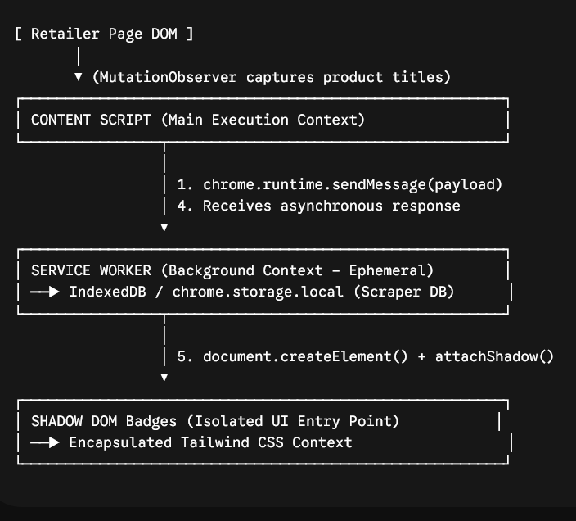

Strict Event-Driven Data Flow Lifecycle
To prevent blocking the main browser thread when a consumer opens a massive checkout or product listing category page, processing follows a strict asynchronous pipeline:
- Discovery: The Content Script runs a MutationObserver on the retailer's product layout grid. It isolates raw elements, extracts product names, and batches them.
- Dispatch: For each unique item, the Content Script issues a non-blocking chrome.runtime.sendMessage() to the Service Worker.
- Activation & Query: The Service Worker wakes up instantly upon receiving the message. It executes an asynchronous index search against the compiled Naivas/Quickmart data stored in chrome.storage.local.
- Fallback/Enrichment: If the item's cryptographic name_hash exists but lacks explicit macro-nutrients, the Service Worker fires an off-thread fetch() request to the Open Food Facts API to calculate the grade on the fly.
- Resolution: The Service Worker utilizes an open channel callback to return the computed payload.
- Isolation Injection: The Content Script receives the payload, generates a custom UI container element, attaches a closed shadowRoot, injects the Tailwind style strings, and renders the specific Nutri-Score badge ($A$ through $E$) directly into the target product card.

Manifest V3 Messaging Matrix
To keep background operations asynchronous and clean, every runtime boundary interaction must follow a strict schema definition. The chrome.runtime.onMessage.addListener handler must return true to signal that the communication channel remains open for asynchronous processing.
Action Identifier | Source Boundary | Destination Boundary | Intent | Expects Async Response?
CHECK_PRODUCT_SCORE | Content Script | Service Worker | Request scoring profile for an extracted item string. | Yes (Returns score object or NOT_FOUND)
ENRICH_OFF_DATA | Service Worker | Open Food Facts API | Populate localized missing values using background fetch loops. | Yes (Updates storage block dynamically)
UPDATE_SHADOW_UI | Content Script | Shadow DOM Component | Inject specific Tailwind visual badge token into isolated root. | No (Direct synchronized DOM paint)

Payload Event Signatures

1. Request: CHECK_PRODUCT_SCORE (Content Script $\rightarrow$ Service Worker)

JSON
{
"action": "CHECK_PRODUCT_SCORE",
"retailer": "naivas",
"payload": {
"product_name": "Jogoo Maize Meal 2KG",
"name_hash": "e3b0c44298fc1c149afbf4c8996fb92427ae41e4649b934ca495991b7852b855"
}
}

2. Success Response (Service Worker $\rightarrow$ Content Script)

JSON
{
"status": "SUCCESS",
"data": {
"product_name": "Jogoo Maize Meal 2KG",
"nutriscore_grade": "A",
"score_details": {
"energy": 345,
"sugars": 1.2,
"sodium": 0.01,
"fiber": 4.5
},
"source": "local_database"
}
}

3. Fallback/Not Found Response (Service Worker $\rightarrow$ Content Script)

JSON
{
"status": "NOT_FOUND",
"data": {
"product_name": "Unknown Local Product",
"nutriscore_grade": "UNKNOWN"
}
}

Performance Optimizations for Checkout Sessions

── Critical Implementation Rule
To ensure the extension maintains a zero-lag user experience during intensive checkouts containing dozens of grocery items, the messaging module forces three technical safeguards:
- The return true Evasion: Because database queries are async, the service worker interceptor code must look exactly like this to prevent premature channel death:
JavaScript
chrome.runtime.onMessage.addListener((request, sender, sendResponse) => {
if (request.action === "CHECK_PRODUCT_SCORE") {
executeAsyncLookup(request.payload)
.then(result => sendResponse({ status: "SUCCESS", data: result }))
.catch(err => sendResponse({ status: "NOT_FOUND", error: err.message }));
return true; // Keeps the messaging channel alive until sendResponse is called
}
});
- Content Script Request Debouncing: Rather than firing 60 individual messages the millisecond a page hydrates, the content script tracks discovered items in a brief 150ms buffer pool before hitting the chrome.runtime interface.
- Storage Fragmentation Strategy: The scraper data inside chrome.storage.local is indexed purely by the cryptographic name_hash. This allows the Service Worker to perform direct key-value lookups in $O(1)$ time complexity, completely eliminating the need to parse large JSON arrays inside the browser memory line during user interactions.

